30 Minutes spent on Assignment
Everything went well once I recalled yesterday.
I am using a very stripped down version of “McClellan -- Assignment – Classes.py” in these tests
Code: 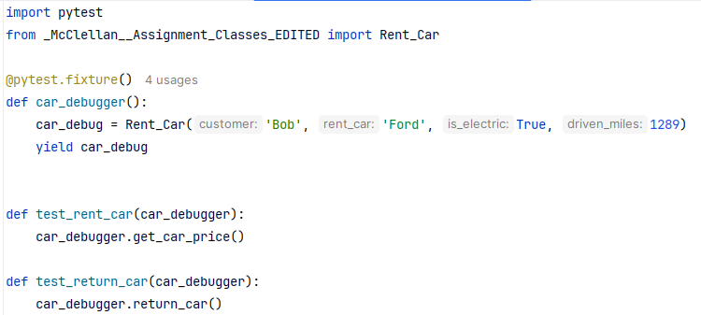
| |
\/ More on the second page \/
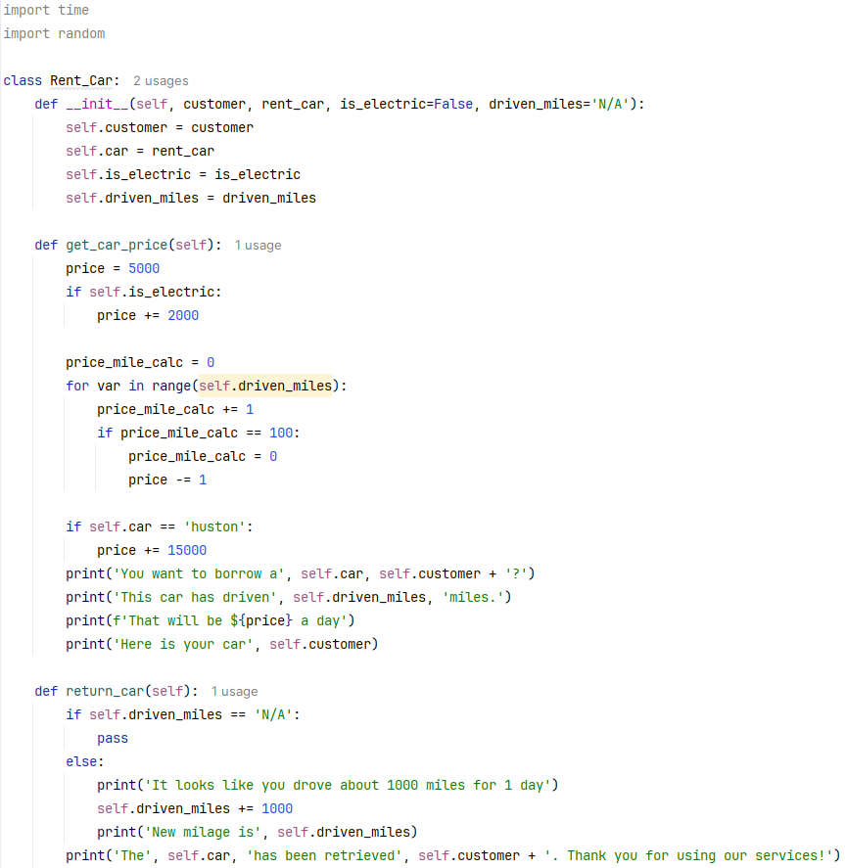

Output:
